Title: …………………………………………………..
Personal datas: | Clothes:  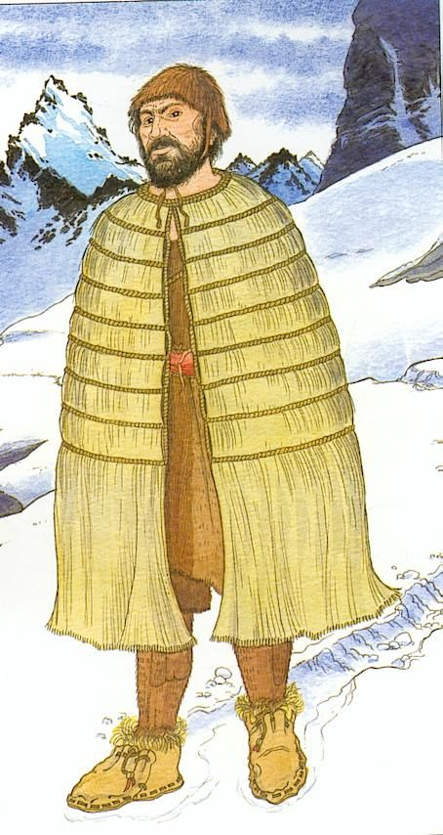
Tools: | Stone Age:

