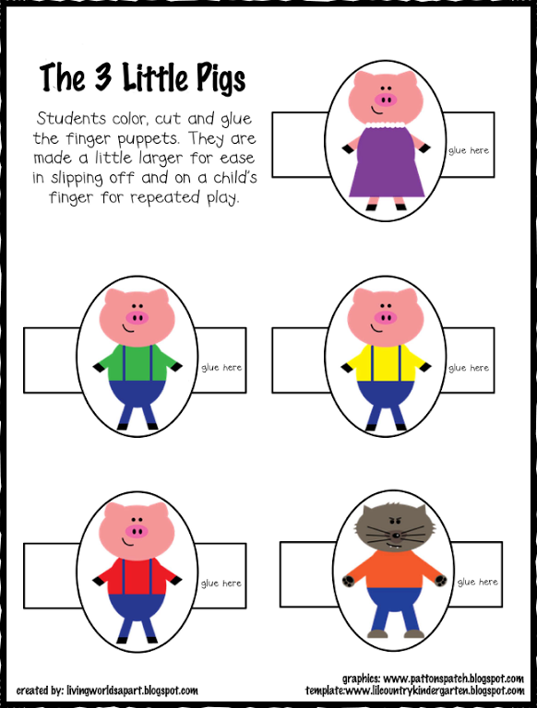
https://www.pinterest.ca/pin/428404983292825456/

